

# GRADE APPEAL INSTRUCTIONS

**General Information:**

The grade appeal process for any course is limited to issues related to grading fairness by the course instructor. A student may appeal a grade when the student believes a) instructor has departed from the standards set out in the course syllabus without a rational academic reason, and/ or b) an error was made in calculating the grade including failure to factor an assignment, quiz, exam or project. Issues that do not meet these criterions are not appropriate for a grade appeal.

For all other complaints, the student should consult the Office of the Dean of Student Affairs and follow the NNMC Student Grievance Policy (https://nnmc.edu/home/studentgateway/student-complaint-process/) and/ or Title IX and gender discrimination policy (<https://nnmc.edu/titleix>/) as applicable.

A student may appeal a grade by using the following procedures mentioned under “Grade Appeal Process”. Only you, the affected student, may challenge or appeal a final course grade (henceforth “grade”) which you feel is improper or incorrect.

Where mentioned, the words College, Dean, and Department head are the Department or College in which the course being appealed is offered. A week consists of five business days or seven calendar days. Grade appeals are not processed during the summer sessions unless the Dean/Chair determines a case warrants immediate review, such as those for students cleared for May graduation.

The grade appeal process is only available before the degree is awarded to the student. Students in their final semester, who have submitted the petition to graduate to the Office of the Registrar should officially inform the instructor of record, the Department Chair/ Director and the Office of the Registrar of their intent to appeal for a course grade within 2 business days after the final grade is posted on Banner (refer to the final grade submission deadline on NNMC academic calendar). Students should refer to Table 1 for deadlines following the policy under “Grade appeal process”. The degree will be placed on hold by the Office of the registrar while the appeal is conducted. If the appeal is granted, the student’s degree will be awarded (with the changed grade) and backdated to the semester when all degree requirements were completed. If the appeal is denied, depending on the reason for the appeal, either the student’s degree will be awarded (without any change to the grade) or the student’s petition to graduate would be denied and the student would have to re-take the class and earn a passing grade.

Important Note: All submissions related to the grade appeal process should be made through NNMC email. In person submission will not be considered as an official submission. The NNMC Academic Standards Committee (ASC) email is [academic-sc@nnmc.edu](mailto:academic-sc@nnmc.edu)

# Grade Appeal Process:

**Step 1)** The student must read and understand the General information of the Grade appeal process and the syllabus of the course in question. The student must initiate the grade appeal process with the course instructor via email by submitting

a) completed (student portion) and signed grade appeal form,

b) a cover letter explaining the exact nature and reason for the grade appeal and,

c) appropriate evidence (refer to supporting evidence list) to support the grade appeal. The student must initiate the appeal with the instructor within the following timeline in **Table 1**:

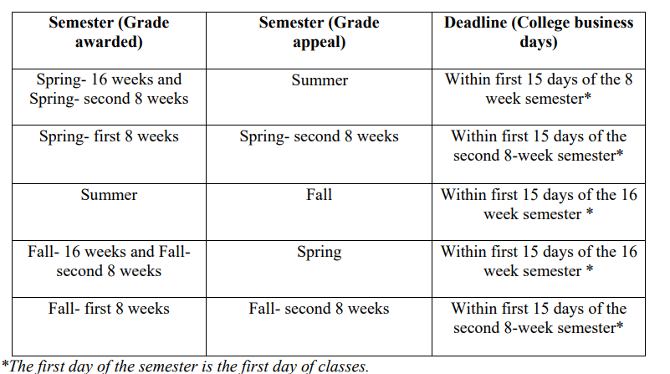

If the student does not receive a response (acknowledgement or decision on the grade appeal) from the instructor (full time/ part time/adjunct/ visiting) within five (5) college business days, the student should submit the grade appeal form along with required documents directly to the Department Chair/ Director/ Dean as mentioned in Step 3. The student is required to submit documentation (email) supporting the non-receipt of any response from the instructor in response to the grade appeal. In this case, Step 2 will be omitted.

**Step 2)** The course instructor upon receipt of this completed form should:

a) record the decision on this form, sign and date,

b) inform the student of his/her decision via email within ten (10) college business days; and

c) return the completed grade appeal form to the student via email and attach a memo/ letter describing in detail the basis for the decision and supporting the decision with documentation (e.g. homework, exam scores etc.). In particular, the instructor should explain the grading procedures and how the grade in question was determined as well as other issues raised in the student's statement.

d) If the grade appeal is granted, the instructor will submit a Change of Grade form to the Office of the Registrar within ten (10) college business days.

**Step 3)** If the appeal is denied at Step 2, the student may continue the appeal with the Department Chair /Director /Dean. The student has five (5) college business days following the decision at Step 2 to continue with the appeal.

a) The Department Chair/Director/Dean will review the grade appeal and attempt to resolve the grade appeal with the instructor and the student within ten (10) college business days. If the grade appeal cannot be resolved, the Department Chair/Director/Dean will send his /her recommendation to the ASC via email and inform the student and the instructor. The recommendation in particular should explain in detail the reason for the denial of the grade appeal.

b) If the grade appeal is resolved, the Department Chair/Director/Dean will inform the instructor with a request to submit a Change of Grade form to the Office of the Registrar within ten (10) college business days. The chair/director/dean should also inform the student via email.

If the student does not receive a response (acknowledgement or decision on the grade appeal) from the Dept. Chair/ Director/ Dean within five (5) college business days, the student should submit the grade appeal form along with required documents directly to the ASC as mentioned in Step 4. The student is required to submit documentation (email) supporting the non-receipt of any response from the Dept. Chair/ Director/ Dean in response to the grade appeal. In this case, Step 3 will be omitted.

**Step 4)** If the appeal is denied at Step 3 by the Department Chair/Director/ Dean, the student may continue the appeal to the ASC via email within ten (10) college business days. The ASC shall review the appeal only if the ASC Review Checklist is complete and hold a meeting (in-person / zoom) within twenty (20) college business days. In case the ASC Review Checklist is not complete, the ASC will inform the student, the Department Chair/Director/Dean and the course instructor of the missing documents via email. The timeline for the ASC review will start the day the complete grade appeal package is received via email. The committee shall submit the final decision to the Dean of students affairs within five (5) college business days after the official meeting.

**Step 5)** The Dean of students affairs shall communicate the Academic Standards Committee final decision on the appeal to the student and the Department Chair/Director/Dean via email within five (5) college business days. If the appeal is granted, the Department Chair/ Director/ Dean will submit a Change of Grade form to the Office of the Registrar within five (5) college business days.

**ACADEMIC STANDARDS COMMITTEE**

GRADE APPEAL SUBMISSION (Step 3)

**CHECKLIST**

THE GRADE APPEAL CASE WILL BE CONSIDERED BY THE ACADEMIC STANDARDS COMMITTEE ONLY IF THIS DOCUMENT CHECKLIST IS COMPLETE. IT IS THE RESPONSIBILITY OF THE STUDENT TO SUBMIT THE COMPLETE PACKAGE TO THE ACADEMIC STANDARDS COMMITTEE.

☐ Cover Letter

☐ Completed and signed Grade Appeal Form

☐ Supporting Evidence (refer to supporting evidence list)

☐ Instructor’s official Grade appeal denial Memo/Letter

☐ Department Chair’s/Director’s/Dean’s official grade appeal denial Memo/Letter

☐ Additional Documents (any document that can help the Committee arrive at a decision)

☐ Checklist

Note: Please submit all the above-mentioned documents as a single file attachment via email to the Academic Standards Committee ([academic-sc@nnmc.edu](mailto:academic-sc@nnmc.edu))

**LIST OF SUPPORTING EVIDENCE**

The supporting evidence should be provided by the student. The list of possible supporting documentation will depend on the particular case. Here is a list of supporting evidence (not exhaustive) that a student can submit

a) Digital copies of specific exams/ assignments and the corresponding grades in question (if available)

b) Specific assignment instructions/ rubrics/corresponding feedback from the instructor

c) Relevant written/digital communications with the Instructor (provide complete record of communication and not selected portions)

d) Course syllabus and grading policy

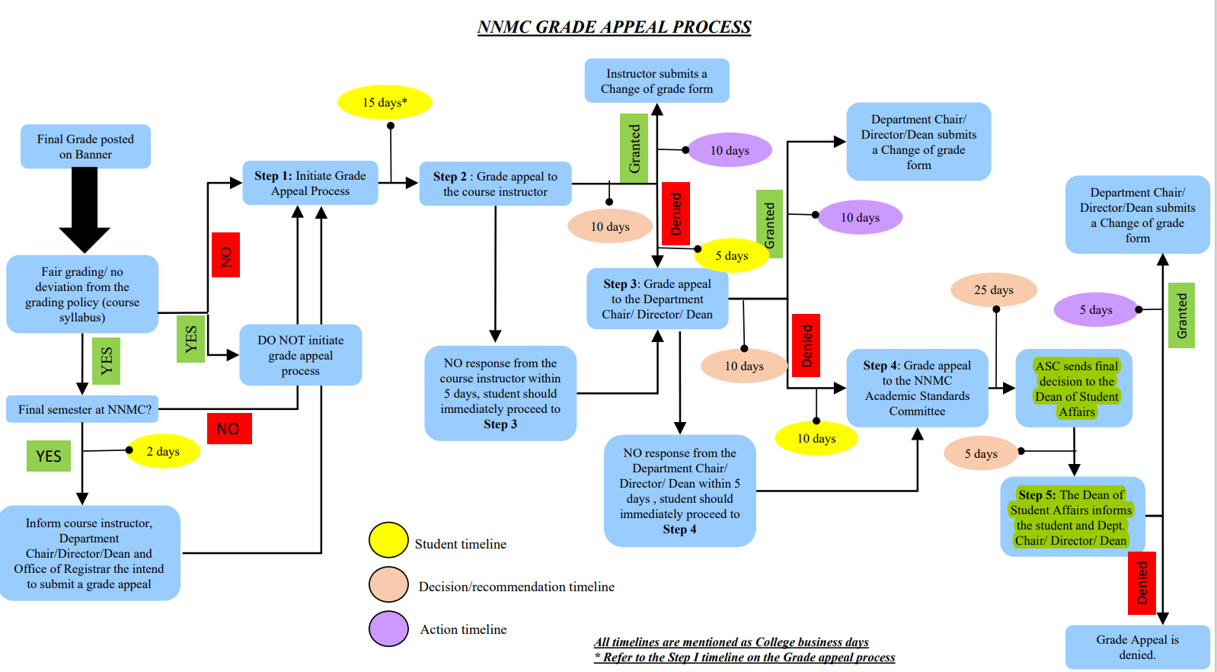

# GRADE APPEAL FORM

**Grade Appeal Information:**

| Course Subject & Catalog Number | CRN | Course Title | Semester & Year |
| --- | --- | --- | --- |
|  |  |  |  |

Instructor’s name:

# Student Information:

Full Name ID

Home Address

Email: Phone

Step 1) Notice to the instructor

Instructor’s Signature Date

Step 2) Instructor’s Decision: (check one) Grant Deny the Appeal

Instructor’s Signature Date

Step 3) Chair/Director’s Decision: (check one)  Grant  Deny the Appeal Chair/ Head Signature Date

Step 4) I have exhausted all administrative appeal channels within the college, and I am forwarding this appeal to the Academic Standards Committee, along with any documentation to support my appeal.

Student Signature Date

# Grade Appeal Academic Standards Committee Decision:

(check one) Grant the Appeal  Deny the Appeal Academic Standards Committee Chair

Signature Date